**Modern Web Technologies – Lab 4:**

**Using MongoDB and MongoSH**

Here is a list of queries I want you to try:

* Comparison queries **[Complete 4 of 6]**
  + Find laptops with the price equal to $999.99.
  + 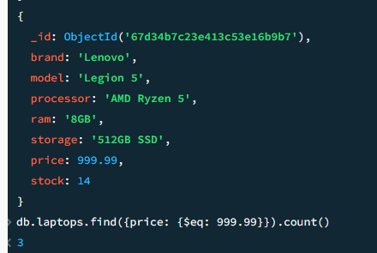
  + Find laptops with prices not equal to $1299.99.
  + 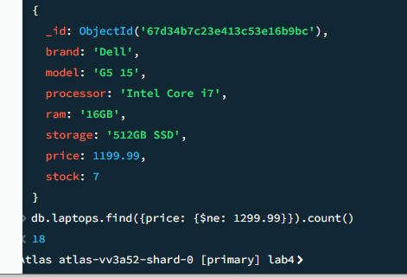
  + Find laptops with a price greater than $1500.
  + 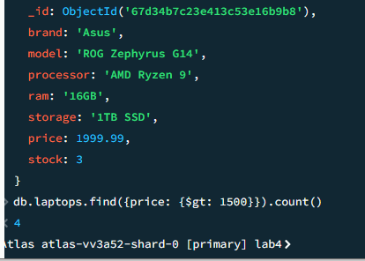
  + Find laptops with a price greater than or equal to $1399.99.
  + 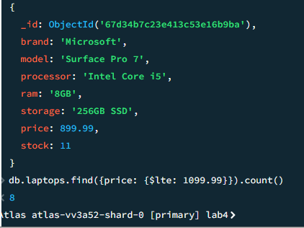
  + Find laptops with a price less than $1000.
  + Find laptops with a price less than or equal to $1099.99.
* Logical queries **[Complete 3 of 4]**
  + Find laptops with a price less than $1000 OR with a stock greater than 10.
  + 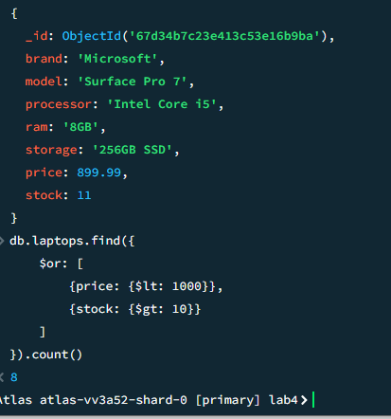
  + Find laptops with a price less than $1000 AND with a stock greater than 10.
  + 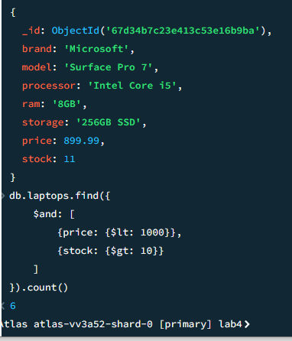
  + Find laptops with a price NOT equal to $999.99.
  + 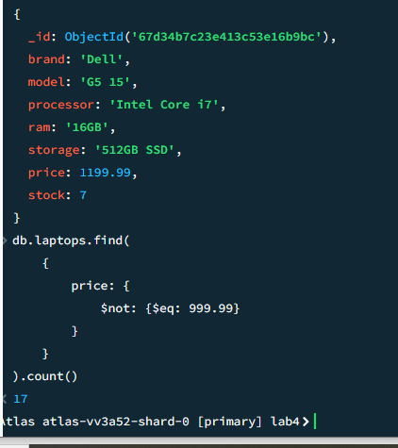
  + Find laptops with a price NOT equal to $999.99 NOR with stock NOT equal to 8.
* Element operators: **[Complete 2 of 2]**
  + Find laptops with the "description" field using **exists**.
  + 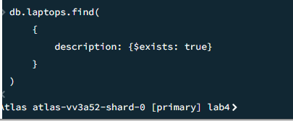
  + Find laptops with the "reviews" field missing.
    - Hint: $exist, you can use 0 and 1 or true and false
    - 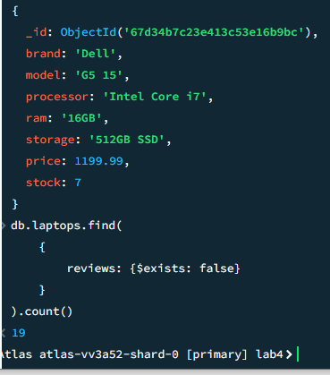
* Array operators: **[Complete 2 of 2]**
  + Find laptops with a genre of "Gaming" in their genres array.
  + 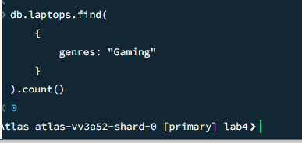
  + Find laptops with the genre "Business" using $in.
  + 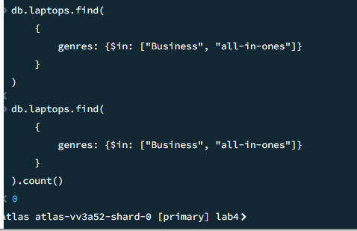
* Text Search Operators: **[Complete 1 of 1]**
  + Perform a text search for laptops with the word "performance".
    - Hint: use the $text tag and the $search tag
    - 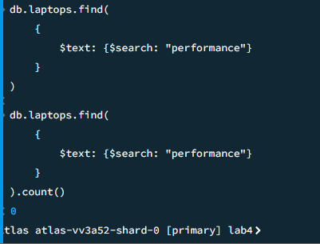
* Array Update Operators: **[Complete 1 of 1]**
  + Add a new review to a laptop with a specific title.
    - (e.g., "Laptop Title", review: user: John Doe, rating: 4)
    - Hint: use the update command and the $push to append a new field of data
    - The review is an array holding the fields user and rating.

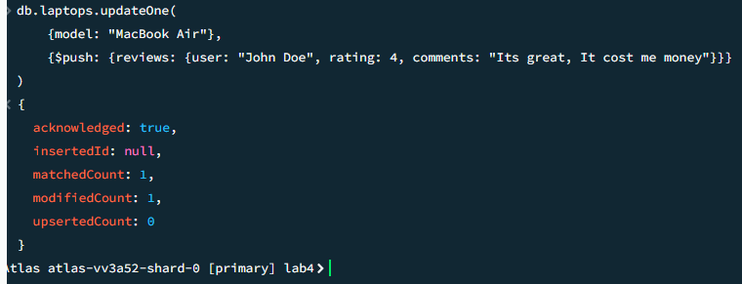

**Submission:**

**Provide me 1 screenshot with each of the query (upwards of 17 total)**

**Provide me a list of the queries you have made, just place them in order of the above order**

**No GitHub Submission required this time**

Grading Scheme:

|  |  |
| --- | --- |
| **Query** | Marks |
| **Comparison** | 8 (2 mark per query completed) |
| **Logical** | 6 (2 marks per query completed) |
| **Element** | 4 (2 marks per query completed) |
| **Array** | 4 (2 marks per query completed) |
| **Text Search** | 4 |
| **Array** | 4 |
| **Total** | 30 |

**Overall Grade weightage: 4 Marks**